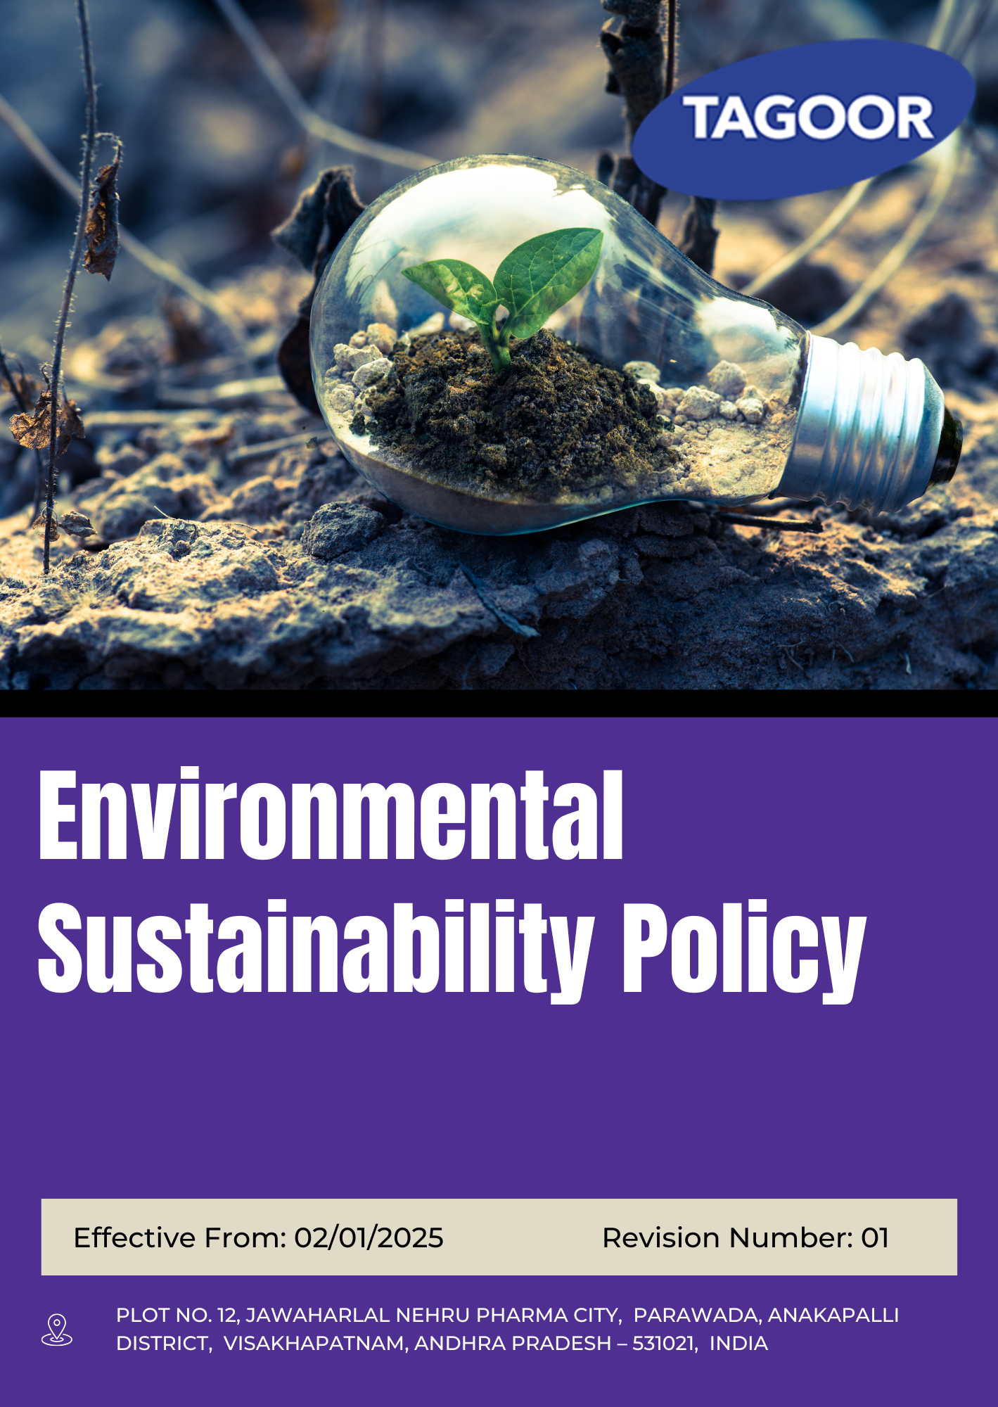

INDEX
1. About this Policy 3
2. Scope & Applicability 3
3. Tagoor’s Environmental Vision and Approach 3
4. Environmental Objectives 4
5. Organizational Responsibilities 4
6. Tagoor’s Environmental targets 5
7. Tagoor’s Environmental key strategies 6
8. Covered Sustainable Development Goals (SDGs) 8
9. Environmental Performance Monitoring and Reporting 8
10. Good Environmental Practices at Tagoor 9
11. Review Mechanism 10
12. Employee Acknowledgement & Commitment Declaration 11

About this Policy
This Environmental Sustainability Policy (“Policy”) is established by Tagoor Laboratories Pvt. Ltd. (“the Company”) to address and manage environmental impacts arising from its operations in the pharmaceutical and chemical manufacturing sector.
The Company is committed to integrating environmental responsibility into its daily operations, business planning, and stakeholder interactions. This Policy outlines the Company’s environmental objectives, key focus areas, performance targets, and the mechanisms for monitoring, evaluation, and continuous improvement.
The Company has adopted appropriate technologies, controls, and best practices to minimize environmental impact and to promote a culture of environmental responsibility and continuous improvement across all levels of the organization.

Scope & Applicability
This Environmental Sustainability Policy ("Policy") applies to all operations, activities, and facilities of Tagoor Laboratories Pvt. Ltd. ("the Company"). It is applicable to all employees at all levels, as well as contractors, suppliers, service providers, business partners, and any other individuals or entities working on behalf of the Company.
Company | Registered Address
Tagoor Laboratories Pvt Ltd | Plot No. 12, Jawaharlal Nehru Pharma City, Parawada, Anakapalli District, Visakhapatnam, Andhra Pradesh – 531021, India.

Tagoor’s Environmental Vision and Approach

The Company has adopted a structured approach to environmental management based on the following principles:

- Prevent: Environmental impacts shall be identified, assessed, and controlled at the planning and operational stages through appropriate systems and practices.
- Comply: The Company shall comply with all applicable environmental laws, regulations, and statutory requirements, and shall align its operations with relevant industry standards.
- Improve: The Company shall strive for continuous improvement in environmental performance through monitoring, evaluation, and implementation of effective environmental management measures.

Environmental Objectives
- To manage environmental impacts associated with pharmaceutical operations through responsible practices and control measures.
- To ensure efficient use of natural resources such as water, energy, and raw materials across all activities.
- To maintain compliance with applicable environmental laws, regulations, and standards.
- To promote environmental awareness and responsibility among employees and relevant stakeholders.
- To adopt environmentally sound technologies and practices to reduce operational impact.
- To support continuous improvement in environmental performance through regular monitoring and review.

Organizational Responsibilities
The following roles and responsibilities apply across the organization:
Role | Designation | Key Responsibilities
Senior Management | Managing Director | Strategic oversight of environmental strategy; ensure alignment with business objectives; allocate financial, technical, and human resources; engage with regulators and industry bodies; oversee environmental risk management and mitigation
Environmental Manager | Environment Officer | Implement and review Environmental Policy; coordinate programs on energy, water, waste, and emissions; ensure regulatory compliance; organize training programs; monitor KPIs and report to management
Sustainability & Compliance Manager | Compliance Manager | Conduct environmental audits and inspections; investigate incidents and ensure corrective actions; maintain reporting systems and documentation; recommend policy improvements; liaise with auditors and regulatory authorities
Operations & Facilities Management | Plant Head | Implement environmental controls; promote resource efficiency; manage waste segregation, storage, and disposal; ensure emergency preparedness for spills and incidents; report risks and incidents
Employee Representatives | Worker Representative | Collect employee feedback; promote environmental awareness; support sustainability programs; act as communication link between workforce and management; encourage participation in initiatives
Employees | All Staff | Comply with environmental policies; use resources responsibly; participate in training; report environmental incidents or risks; follow sustainable practices in daily operations

Tagoor’s Environmental targets

Focus Area | Target | Baseline Year | Target Year
Climate & Energy | Reduce energy consumption intensity by 10% vs 2023 baseline | 2023 | 2030
Climate & Energy | Implement energy monitoring systems covering 90% of major energy-consuming equipment | 2023 | 2030
Climate & Energy | Achieve 7% renewable energy share in total consumption | 2023 | 2030
Climate & Energy | Improve utility system efficiency by 8% | 2023 | 2030
Climate & Energy | Reduce Scope 1, Scope 2 & Scope 3 GHG emissions by 8% | 2023 | 2030
Climate & Energy | Reduce overall energy losses by 5% | 2023 | 2030
Water Stewardship | Reduce freshwater consumption by 8% | 2023 | 2030
Water Stewardship | Reuse 35% of treated water within operations | 2023 | 2030
Water Stewardship | Achieve 100% monitoring of water consumption across major processes | 2023 | 2030
Water Stewardship | Reduce water losses due to leakage/inefficiency by 10% | 2023 | 2030
Water Stewardship | Improve overall water use efficiency by 10% | 2023 | 2030
Waste Management | Reduce hazardous waste generation by 7% | 2023 | 2030
Waste Management | Achieve 100% segregation of hazardous and non-hazardous waste | 2023 | 2030
Waste Management | Reduce material losses in operations by 8% | 2023 | 2030
Waste Management | Ensure 100% compliance in chemical storage and handling | 2023 | 2030
Waste Management | Reduce waste sent for disposal by 10% | 2023 | 2030
Air Quality | Maintain 100% compliance with applicable emission standards | 2023 | 2030
Air Quality | Improve emission control system efficiency by 10% | 2023 | 2030
Air Quality | Achieve 100% monitoring of key emission sources | 2023 | 2030
Air Quality | Reduce emission intensity by 8% | 2023 | 2030
Air Quality | Maintain zero emission-related incidents | 2023 | 2030
Biodiversity | Increase green cover by 10% | 2023 | 2030
Biodiversity | Maintain 100% of greenbelt areas effectively | 2023 | 2030
Biodiversity | Implement 3 biodiversity initiatives | 2023 | 2030
Product Lifecycle | Ensure 100% adherence to product handling and disposal guidelines | 2023 | 2030
Product Lifecycle | Apply lifecycle considerations in 25% of major processes | 2023 | 2030
Product Lifecycle | Maintain 100% compliance with disposal regulations | 2023 | 2030
Product Lifecycle | Achieve 100% awareness of lifecycle practices among stakeholders | 2023 | 2030
Customer Health & Safety | Maintain 100% compliance with product quality standards | 2023 | 2030
Customer Health & Safety | Achieve 100% monitoring of product quality parameters | 2023 | 2030
Customer Health & Safety | Ensure 100% product traceability | 2023 | 2030
Customer Health & Safety | Maintain zero major customer safety incidents | 2023 | 2030
Awareness & Training | 100% employee environmental training annually | 2023 | 2030
Awareness & Training | Conduct 4 awareness programs per year | 2023 | 2030
Awareness & Training | Increase employee participation in initiatives by 40% | 2023 | 2030
Awareness & Training | Ensure 100% environmental communication coverage | 2023 | 2030
Environmental Compliance | Maintain 100% environmental regulatory compliance | 2023 | 2030
Environmental Compliance | Ensure 100% documentation compliance | 2023 | 2030
Environmental Compliance | Conduct annual environmental audits across 100% facilities | 2023 | 2030

Tagoor’s Environmental key strategies

To achieve the targets outlined above, the Company has implemented the following strategies:
- Climate and Energy Management

- Implement energy management systems across major energy-consuming equipment to enable continuous monitoring and control of energy use.
- Conduct periodic energy audits and identify opportunities for energy efficiency improvements in utilities and processes.
- Promote adoption of energy-efficient technologies and equipment upgrades.
- Increase use of renewable energy sources through on-site or external procurement mechanisms.
- Implement GHG emission tracking and reporting system covering Scope 1, 2, and relevant Scope 3 emissions.
- Reduce energy losses through preventive maintenance and optimization of operational processes.
- Reducing Scope 3 emissions by collaborating with suppliers, optimizing logistics, adopting cleaner technologies, and integrating circular economy principles to minimize emissions across the value chain.
- Water Stewardship

- Install water metering and monitoring systems across major processes to ensure real-time tracking of water consumption.
- Implement water conservation practices including reuse and recycling of treated wastewater.
- Optimize process water usage through efficient equipment and operational controls.
- Identify and repair leakage points through regular inspections and maintenance programs.
- Promote water efficiency awareness among operational teams.

- Waste Management & Chemicals Handling

- Strengthen waste segregation systems to ensure 100% separation of hazardous and non-hazardous waste.
- Implement waste minimization practices at source through process optimization.
- Ensure safe storage, handling, and disposal of chemicals in compliance with regulatory requirements.
- Reduce material losses through improved inventory management and process control.
- Promote recycling and recovery opportunities wherever feasible.

- Air Quality Management

- Install and maintain effective emission control systems across all relevant operational units.
- Conduct regular monitoring of air emission sources to ensure compliance with regulatory standards.
- Improve operational efficiency of pollution control equipment through preventive maintenance.
- Implement emissions tracking systems to monitor intensity and reduction progress.
- Maintain strict incident prevention mechanisms for air emission-related events.

- Biodiversity Management

- Develop and maintain greenbelt areas within and around operational sites.
- Undertake plantation and afforestation initiatives to enhance green cover.
- Implement biodiversity conservation programs in alignment with local ecological conditions.
- Monitor and maintain green areas to ensure long-term sustainability.

- Product Lifecycle Management

- Integrate environmental considerations into product handling, storage, and disposal processes.
- Promote lifecycle thinking in selected operational processes and decision-making.
- Ensure compliance with all product disposal and regulatory requirements.
- Strengthen awareness among employees and stakeholders on lifecycle impacts and responsibilities.

- Customer Health and Safety

- Maintain strict quality assurance and regulatory compliance across all products.
- Strengthen product monitoring and traceability systems across the supply chain.
- Implement preventive risk management systems to avoid product-related safety incidents.
- Conduct periodic safety reviews and corrective action implementation.

- Awareness & Training

- Conduct structured environmental training programs for all employees on an annual basis.
- Organize regular awareness campaigns to promote sustainability culture within the organization.
- Increase employee participation in environmental initiatives through engagement programs.
- Ensure consistent communication of environmental policies and updates across all departments.

- Environmental Compliance

- Ensure full compliance with all applicable environmental laws and regulatory requirements.
- Maintain complete and accurate environmental documentation and records.
- Conduct periodic internal environmental audits across all facilities.
- Implement corrective and preventive actions based on audit findings.
- Strengthen environmental governance through monitoring and reporting systems.

Covered Sustainable Development Goals (SDGs)
 | 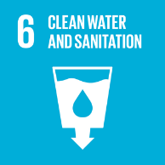 | 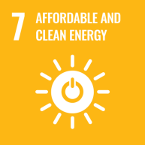 |  |  | 

Environmental Performance Monitoring and Reporting
At Tagoor Laboratories Pvt Ltd, structured monitoring and reporting systems are established to track environmental performance and ensure continuous improvement.
- Monitoring: Key environmental parameters (energy, water, waste, emissions) are monitored against defined KPIs on a monthly basis. Results are compiled into quarterly performance dashboards for management review.
- Internal Audits: Environmental compliance audits are conducted at least once a year for all applicable facilities. Audit findings are reported to senior management and corrective actions tracked to closure.
- Management Review: Senior management reviews environmental performance, audit outcomes, and target progress at least annually. Outputs from the management review feed into target-setting and policy updates.
- External Reporting: Environmental performance is disclosed through applicable external frameworks and regulatory filings.

Good Environmental Practices at Tagoor

Tagoor Laboratories Pvt. Ltd. promotes responsible environmental behaviour through the following good practices to be followed by all employees:

Do’s
- Use energy, water, and materials efficiently and avoid unnecessary consumption.
- Switch off lights, equipment, and machinery when not in use.
- Segregate waste at source as per defined categories (hazardous / non-hazardous / recyclable).
- Follow proper procedures for handling, storage, and disposal of chemicals.
- Report any leaks, spills, or environmental hazards immediately.
- Use designated bins and disposal systems for all types of waste.
- Follow all environmental procedures, SOPs, and safety instructions.
- Participate in environmental training and awareness programs.
- Support initiatives related to recycling, reuse, and resource conservation.

Don’ts
- Do not waste water, electricity, or raw materials.
- Do not mix different types of waste or dispose waste in unauthorized areas.
- Do not discharge chemicals, oils, or waste into drains or open areas.
- Do not handle chemicals without proper authorization and PPE.
- Do not ignore spills, leaks, or unsafe environmental conditions.
- Do not bypass pollution control systems or safety measures.
- Do not burn waste or dispose of it improperly.
- Do not operate equipment in a way that may cause environmental harm.

Review Mechanism
This Environmental Sustainability Policy is subject to periodic evaluation by the Environmental Manager at least once every two years, or earlier if required due to regulatory changes, operational developments, or stakeholder feedback to ensure its continued relevance, effectiveness, and alignment with evolving legal requirements, regulatory standards, and organizational priorities.
The review encompasses an assessment of compliance status, progress against established environmental targets, and inputs from relevant stakeholders. Based on this evaluation, necessary updates are incorporated to strengthen the policy framework and ensure alignment with current regulations, industry best practices, and the Company’s commitment to continuous environmental improvement.

Prepared By:

Approved By:

Last Review date: 01/01/2026

Next Review date: 01/01/2028

Employee Acknowledgement & Commitment Declaration

I, the undersigned employee of Tagoor Laboratories Pvt. Ltd., hereby acknowledge my participation in the Company’s environmental responsibility framework and confirm the following commitments:

1. Awareness Confirmation

☐ I confirm that I have received the Environmental Sustainability Policy
☐ I have read and understood its purpose, scope, and requirements
☐ I understand how it applies to my role and workplace activities

2. Commitment to Compliance
☐ I agree to comply with all applicable environmental procedures and controls
☐ I will follow safe and responsible environmental practices in daily operations
☐ I will support the Company’s efforts to meet legal and regulatory requirements

3. Active Participation

☐ I will participate in environmental training and awareness programs
☐ I will support initiatives related to energy, water, waste, and emissions reduction
☐ I will contribute to improving environmental performance in my area of work

4. Responsibility & Reporting

☐ I will report environmental risks, incidents, or non-compliance without delay
☐ I will communicate improvement opportunities to Environmental Officer
☐ I understand my role in preventing environmental harm through responsible action

5. Continuous Improvement Mindset
☐ I acknowledge that environmental protection is an ongoing responsibility
☐ I commit to supporting continuous improvement in environmental practices

Employee Name:
Acknowledgement Date:
Signature:

